Policy Name | Student Research Award Policy
Proposed By | Director ORIC
Reviewed By | Registrar and Pro-VC
Approved By | ORIC Steering Committee
Effective From | 01-07-2026
Next Review Date | 30-06-2028
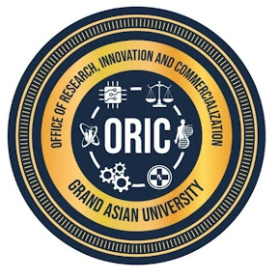
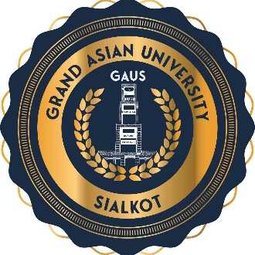
- Purpose
The Student Researcher Award policy is established to recognize and reward outstanding research achievements of graduating students who demonstrate excellence in scholarly research, innovation, publication, and academic integrity. The award aims to encourage a vibrant research culture among students and inspire future researchers by recognizing exceptional academic and research accomplishments.
- Objectives
The objectives of the award are to:
- Promote a culture of research and innovation among students.
- Encourage publication of high-quality research in reputable journals.
- Recognize outstanding thesis and dissertation research.
- Foster research with societal, industrial, and policy impact.
- Encourage timely completion of graduate studies.
- Enhance the University's national and international research profile.

- Scope
This policy is applicable to all the BS, MS, and PhD students enrolled in Islam Group and Grand Asian University Sialkot.
- Eligibility Criteria
This award will be conferred upon the graduating participants of BS, MS/MPhil, and PhD, fulfilling the following conditions:
- Have successfully completed all degree requirements and be eligible for graduation.
- Have obtained a minimum CGPA of 3.50/4.00 for PhD, MS/MPhil and 3.00/4.00 for BS (where applicable).
- Have completed the degree within the prescribed duration (2 Years for MS, 3 Years for PhD, 4 Years for BS, 5 Years for programs like, DPT and Pharm D.
- Have published at least: One (1) paper in an HEC-recognized, based on the student's thesis.
- Be listed as the first author or corresponding author, or must be the 2nd author if the Supervisor is first author.
- Clearly mention Grand Asian University as the institutional affiliation.
- Number of Awards
Unless otherwise approved by the competent authorities, the following awards shall be presented annually:
- Up to Three (3) awards for BS students.
- Up to Three (3) awards for MS/MPhil students.
- Up to Three (3) awards for PhD students.
To ensure disciplinary balance, the Awards Committee may recommend separate recipients from:
- Basic/Food/Health and Life Sciences
- Computer/Engineering and Technology
- Social Sciences/Business, Management and Law

- Award and Recognition
Each recipient shall receive a Certificate of Research Excellence in recognition during the Convocation or Annual Research Awards Ceremony
Nominations shall be invited by ORIC each academic year.
Each nomination shall include:
- Nomination Form
- Thesis abstract
- Publication(s)
- Proof of publication/indexing
- CGPA transcript
- Supervisor's recommendation
- Evidence of conferences, patents, or other research achievements (if applicable)
- Policy Review and Amendments
This policy shall be reviewed every two years, or earlier if required, to ensure alignment with the University's strategic priorities, HEC regulations, emerging technologies, and international best practices. Amendments shall be approved by the appropriate statutory bodies of the University.

Proposed By: Approved By:

Director ORIC Vice Chancellor/ Chairman ORIC-SC
Grand Asian University Sialkot Grand Asian University Sialkot

